11.6: The other person lifts with a force of 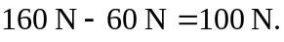 Taking torques about the point where the 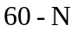force is applied,
